Report: Regional vs. National Housing Price Comparison
[Your Name]
Southern New Hampshire University

Introduction
Purpose:
The report aims at determining the relationship of the housing square footage and prices within the East South Regions and how they tend to differ significantly from the data in the National Market. In the development of the report, I considered sampling 100 houses randomly within the East South Region. We will utilize the randomly sampled data to prove if indeed the housing prices within the Region are high compared to the national market data. We will also be able to determine whether the square footage of home within the Region differ with that I the national market.

Sample:
The sample of the data selected of 100 homes within the East Central Region if from these few states; Kentucky, Alabama, Mississippi, and Tennessee. The data further includes the county they are found in, square footage of homes, housing listing price, and each home's cost per square footage.
Questions and type of test:
In this report, we aim to conduct two tests differently, of which we will be using α = .05 as the significance level for both tests.
We let the u=mean housing prices within the regions.
Null Hypothesis (H0) will be H0: u=288407 and the Alternative Hypothesis (H1) be
u greater than 288407.
A.The population parameter remains to be the mean housing price of the randomly selected homes within the Region.
B.Hypothesis; we find if the mean price of houses in the Region is equal or greater than the prices of houses nationally.
C.Use the t-test to determine the existing mean difference between the two groups.
We let the u=mean square footage within the regions.
Null Hypothesis (H0) will be H0: u=1944 and the Alternative Hypothesis (H1) be H1: u NOT =1944.
A. The population parameter remains to be the mean housing price of the randomly selected homes within the Region.
B. Hypothesis; we find if the mean square footage of houses in the Region is equal to or higher than the prices of houses nationally.
C. Use the t-test to find the existing difference between the Region we choose and the national market.

1-Tail Test
Hypothesis:
Basing on the mean housing price within our selected Region, East South Central,
Let the symbol u be equal to the mean housing price of the Region,
H0: u =288,407
H1: u >288,407
The significance level =.05
Data analysis:
We do not reject H1, and the reason for this is that the p-value is greater than the significance level. In simple terms, this means that the mean housing price within our selected Region (East South Central) is not greater than or equal to that in the national market. Thus, the prices of houses in this Region are lower than the average nationally.
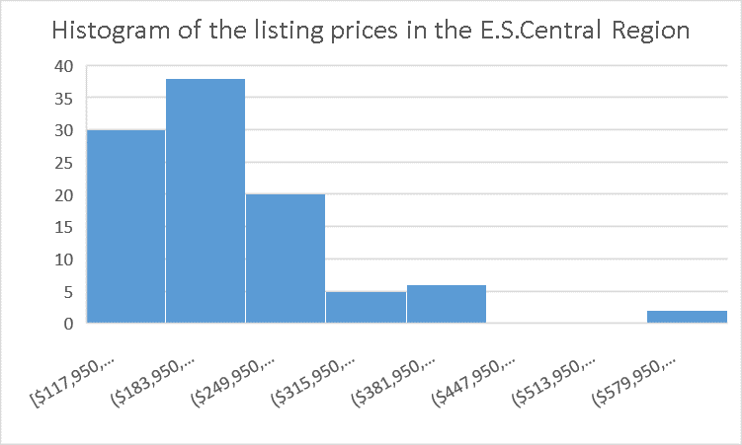
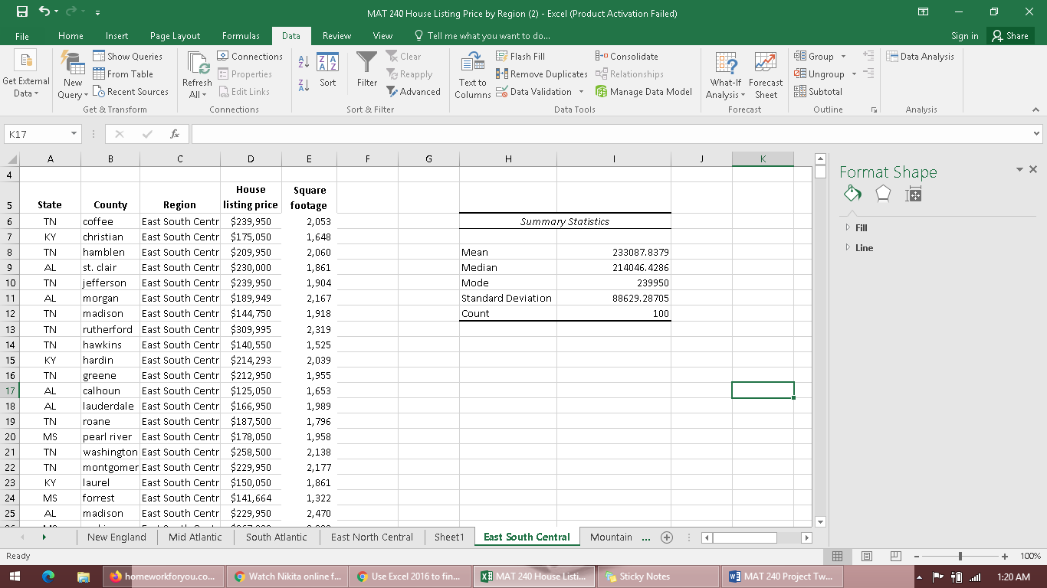
The above-sampled data in the East South region has a mean of $233087.8379 and the Median of $214046.4286. This is an indication that several houses selected in the Region for analysis tend to have a very close price range. The standard deviation of the sampled data is 88629.28705. This, on the other hand, indicates that not much spread in the sampled data and the curve shape is symmetric.
The normal condition has been met. The data was sampled randomly from the selected Region's entire population (East South Central Region), and the variables produce a normal distribution. Considering the central limit theorem that states; when you have any population sample with a mean (u), the distribution means will approximately be distributed normally. In this this, it is a true scenario.

Hypothesis Test Calculations:
T Test = (– x̄ μ) / (σ / √n)
T-Test= (233087.84 – 288,407) / (88629.29 / √100)
= -6.24163411
To find the p value, we key the T.DIST.RT function in Excel
=T.DIST.RT ([test statistic], [degree of freedom])
We always subtract 1 from our sampled size in order to get the degree of freedom.
=T.DIST.RT ([-6.24], [100-1])
P value =0.999999995
Interpretation:
We found our p-value as 0.999999995. This is greatly higher than our significance level, which is .05. In this case, we fail to reject the null Hypothesis since our p-value is much higher than the significance level. In conclusion, the mean housing price within the East South Central Region is not equal to that of the national market. They are greatly lower compared to the national average prices.

2-Tail Test
Hypotheses:
The population parameter is the mean square foot of homes within the East South Central region. Because we just considered apportion of the entire population, the population parameters remain to be unknown. Our significance level = .05.
U= Mean square footage within the East South Central Region
H0: u=1944
H1: u NOT=1944
Data Analysis:
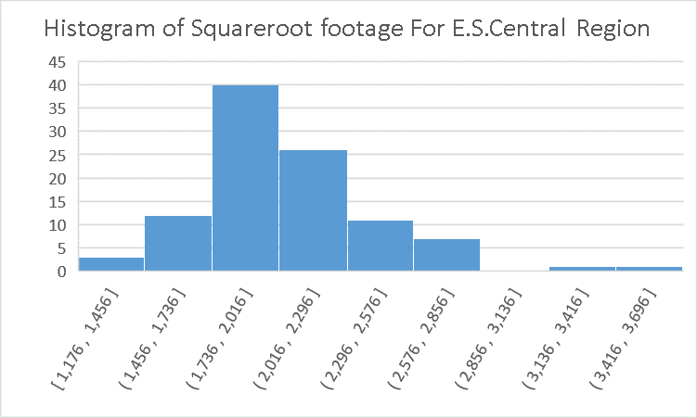
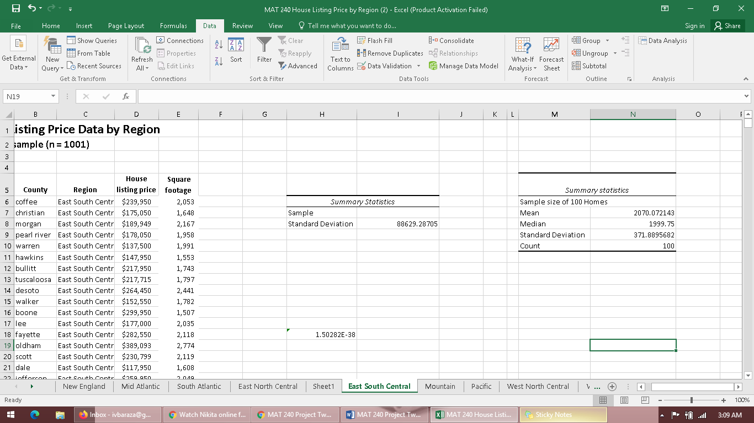
The above sampled data in the East South region has mean square footage of 2070 and the Median of 1999. This is an indication that several houses selected in the Region for analysis tend to be very close in Square footage. The standard deviation of the sampled data is 371.89, thus indicating how data is not much spread and the shape of the curve is symmetric.
The normal condition has been met. The data was sampled randomly from the selected Region's entire population (East South Central Region), and the variables produce a normal distribution. Considering the central limit theorem that states; when you have any population sample with a mean (u), the distribution means will approximately be distributed normally. In this this, it is a true scenario.
Hypothesis Test Calculations:
We utilize the following formula to find our test statistic:
T Test = (– x̄ μ) / (σ / √n)
= (2070.07 – 1,944) / (1999.75/ √100)
=0.6304288
To find our p value, we key this (T.DIST.2T) function in Excel
T.DIST.2T ([test statistic], [degree of freedom])
=T.DIST.2T ([0.63], [100-1])
=0.530145986
Thus, our p value > α
Interpretation:
Our p-value (0.53) is greater than our significance level of .05.
We fail to reject our NULL Hypothesis since our p-value is greater than our significance value. We then conclude that there is no enough data to give support to the assumption that the mean square footage of homes from our selected Region (East South Central Region) differs from that in the national market. I would again conclude that this was expected because, having a look at our summary statistics, there is an extreme similarity with that in the National Market.

Comparison of the Test Results:
For us to determine the confidence interval, we need to identify the margin of error. Typing (confidence.t (.05, standard dev square footage, sample size) in excel. We find the margin error as 73.79095853. This is approximately 73 (≈ 73). Using the margin of error to determine our upper bound and lower bound, we add and subtract our margin of error to the mean of our sampled data.
Upper bound = x̄ + m = 2070 + 73 = 2143
Lower bound = x̄ - m = 2070 – 73= 1997
Having found the results above, we can be 95% confident that the average mean square footage for homes in our selected Region (East South Central) falls between 1997 and 2143.

Final Conclusions
Considering the Region's results, I selected which is the East South Central region; my overall conclusion is that the results for the sampled data were expected. In terms of square footage, the houses are larger, and the prices of homes remain lower than the data in the national market. Despite this being expected, it remains to be very insightful indeed. I am not surprised by the results. This is because I have been in various states of the Region, and I have been reading about the prices of homes in the Region.

